GUIDE FOR MEMBERS

Flex Membership



TABLE OF CONTENTS

HOME ………………………………………………………………………………………. 3
TOP UP YOUR WALLET …………………………………………………………….. 5
MAKING A BOOKING ………………………………………………………………… 7
AMENDING A BOOKING ……………………………………………………………. 8
WALLET TRANSACTIONS …………………………………………………………. 8

Flex Membership is a new feature based on the BRS Memberships solution, developed by
BRSGolf and GOLFNOW. Flex Membership allows you, as a member, to have a wallet that holds points, points are deducted for each booking, and you can top-up your wallet online.

This guide will show you how to use Flex Membership through the BRS Members Booking Module and/or the BRS Members APP.


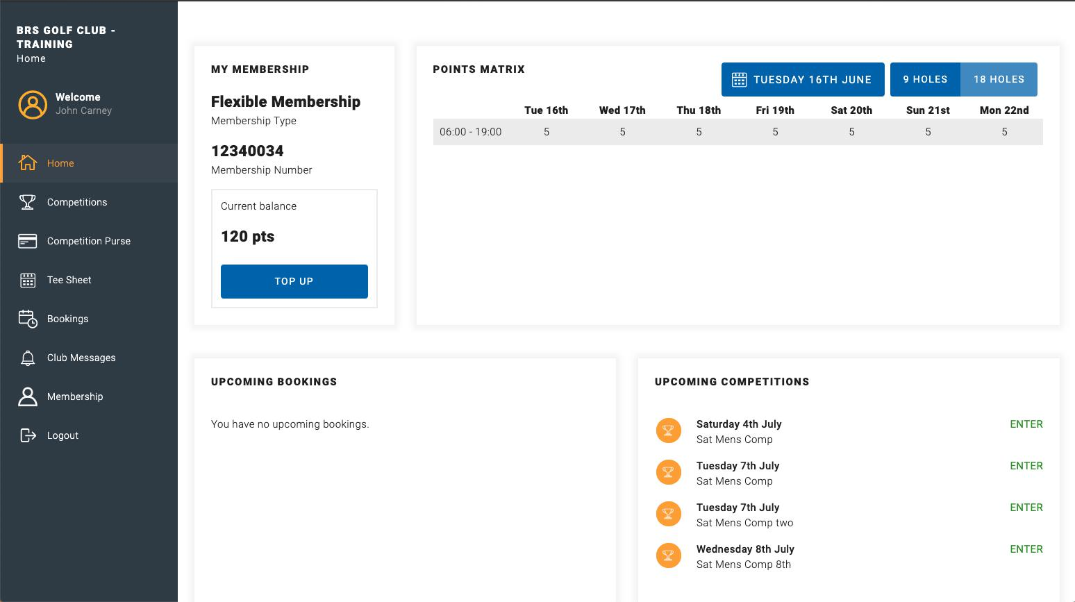
HOME

As a member using the Flex Membership feature, you will see the My Membership and Points Matrix displayed on the home page through your existing member login.

Points Wallet

Your current points balance will be displayed in the My Membership section of the home page. Your club may have transferred points from an existing system, if used. Later in this guide you will see how you can top up your points wallet.

Points Matrix

The Points Matrix displays the number of points it will cost you to play for the next 7 days in the time bands your club has created. By tapping or clicking on 9 Holes or 18 Holes you can view the points it will cost you to play. If you have a specific date you want to play, you can click on the calendar and select it, the points matrix will refresh and display the selected date as the starting date.


TOP UP YOUR WALLET

If you have insufficient funds to make a booking, you need to top up your wallet. On the Home page, click Top Up:
- Choose the amount you wish to top up. You may have the option to select Other and input the amount you wish to top up.

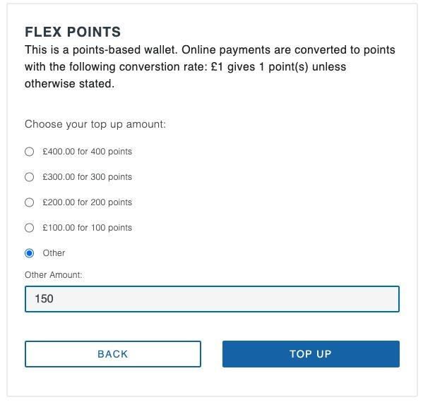

- Click Top Up

- Complete all the mandatory fields on this page – these are marked with an *.
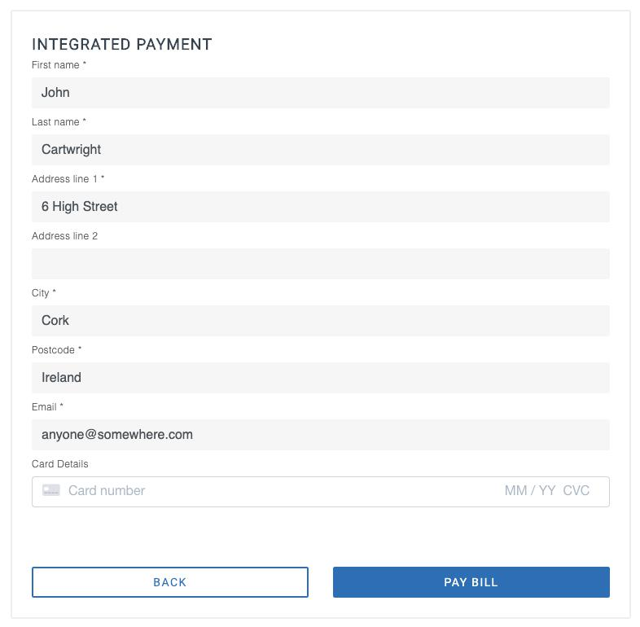

- Complete Card Number, Expiry month/year and CVC

- Click Pay Bill

The payment completes and your wallet is topped up. You will receive an email confirming payment has completed.

Your card details are saved in the system to use for future top ups. Later in this guide you see how you can change your card details.

Should you have any issues with your card the error message will display on the screen, like this one.

The top up option is available Membership > My Wallets and clicking on the plus icon, highlighted below.

MAKING A BOOKING
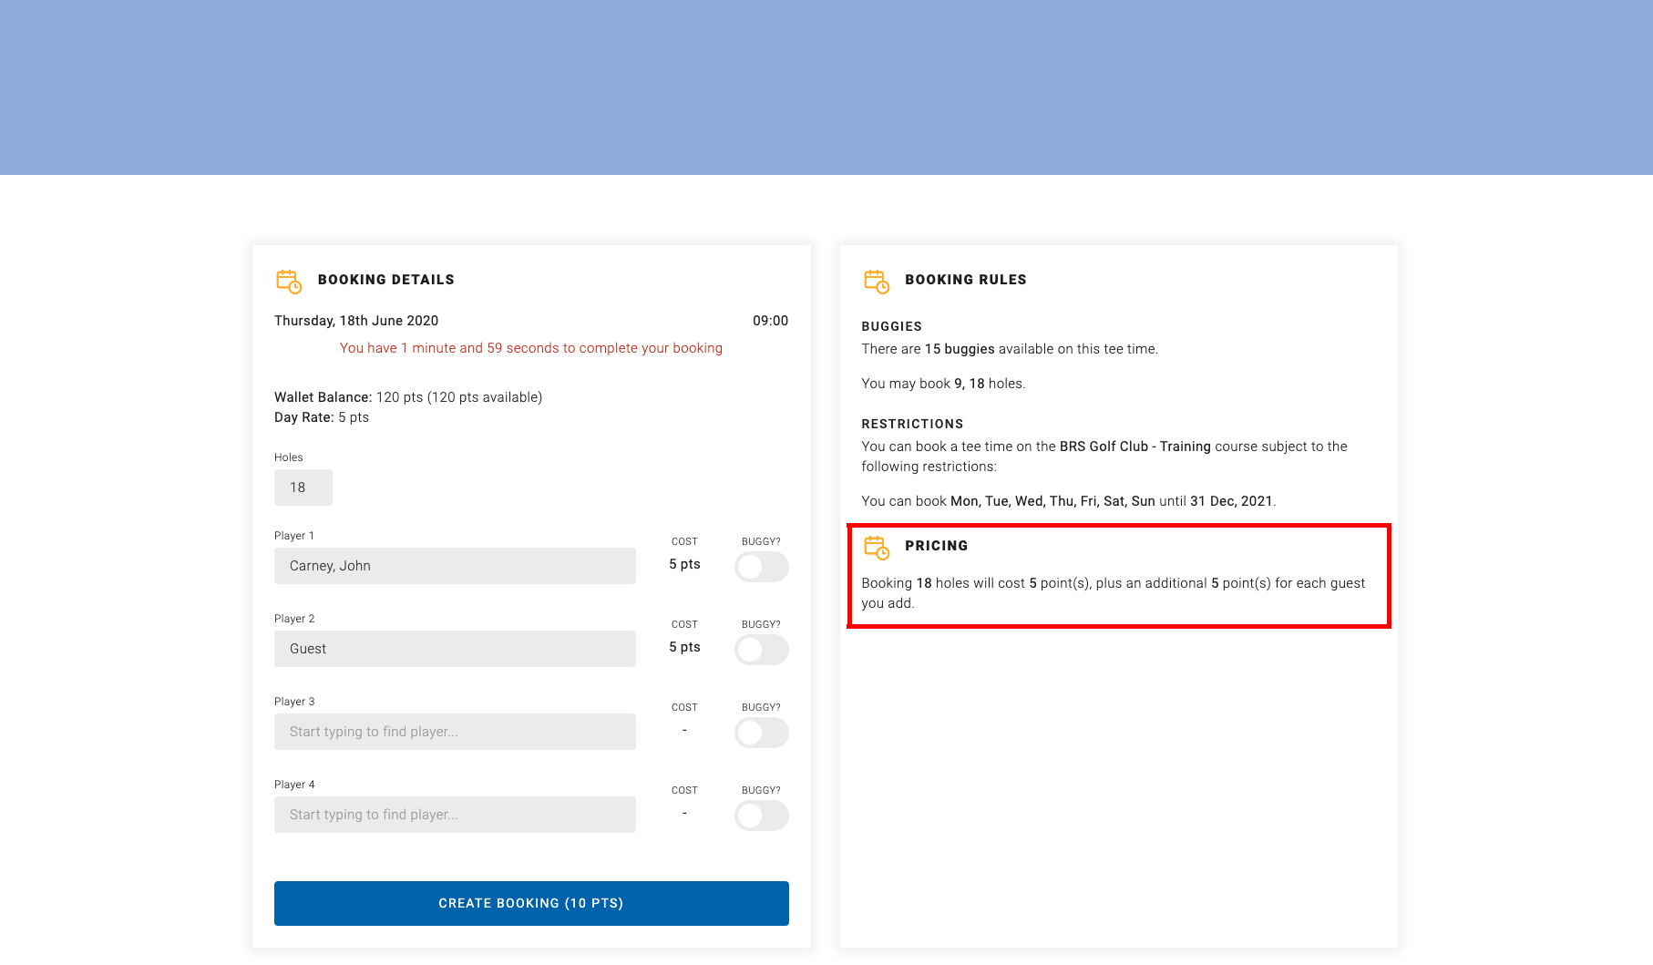
MAKING A BOOKING

When you make a booking, either for a competition or for casual golf, points will be deducted from your wallet for you and any guests you have included in your booking. If you include another flexible member in your booking, they will pay for themselves through their own points wallet.

The booking details displays the number of points the tee time will cost you, highlighted above.

If you have insufficient points in your wallet the booking will not complete.

Once the booking completes, the points will be deducted from your wallet.

TOP UP YOUR WALLET

AMENDING A BOOKING

AMENDING A BOOKING

Any amendments to a booking may result in points being refunded to your wallet, if, for example, you remove guests from your booking.

If you cancel a booking, all points will be refunded to your wallet.

WALLET TRANSACTIONS

WALLET TRANSACTIONS

You can view your wallet transactions through Membership > My Wallets. All wallet top ups and purchases are shown for the last 30 days.
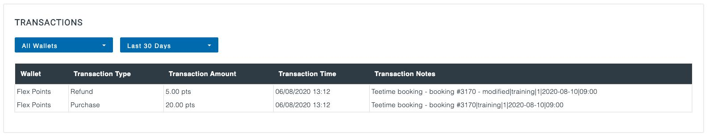

You can change the select to view wallet transactions for the last 60 or 90 days.

